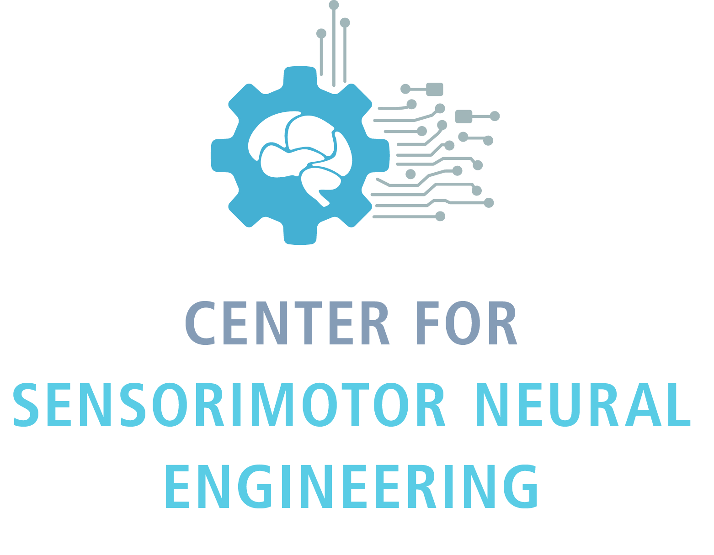
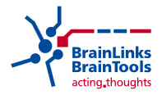
Center for Sensorimotor Neural Engineering / BrainLinks-BrainTools
Summer Research Program

Application Deadline for Summer 2017: March 1, 2017

The Center for Sensorimotor Neural Engineering (CSNE) and BrainLinks-BrainTools Cluster of Excellence have a common interest in developing systems that interact with and are inspired by neural systems, and have therefore agreed on a strategic partnership. In order to facilitate mutual learning, to stimulate the exchange of ideas, and to strengthen this partnership, the CSNE and BrainLinks-BrainTools are pleased to announce a student exchange program for summer research experiences. This activity is aligned with the mission of NSF and DFG to promote young researchers and to foster international collaboration. For more information about the research programs at the CSNE and BrainLinks-BrainTools, see:

http://www.csne-erc.org and http://www.brainlinks-braintools.uni-freiburg.de/

Applicants to this summer research program must:
- Be an undergraduate student, graduate student, or postdoctoral researcher associated with a core partner CSNE institution (UW, MIT or SDSU) or BrainLinks-BrainTools and/or their training programs. Preference will be given to student/post-doc researchers who already receive CSNE stipends, but all researchers are welcome to apply.
- Be a citizen or permanent resident of the United States (CSNE applicants only).
- Devote 40 hours per week to the program.
- Attend weekly classes, journal club meetings, and other lectures, seminars, focus groups and workshops required by the CSNE or BrainLinks-BrainTools.

Participants will receive:
- The opportunity to learn new techniques, work in a new, exciting research environment, and form collaborations with other investigators.
- Travel to and from your home country (covered by the home institution).
- Support towards living expenses during the stay abroad (covered by the home institution).
- Housing at the host institution (covered by the host institution).
- Possible academic credit (BrainLinks-BrainTools applicants only; CSNE applicants will not receive academic credit).

Application Materials: Your application will not be reviewed until we receive all of the following materials:

- Completed application form

- Reference letter from current academic advisor

Email these materials to both Eric H. Chudler, Ph.D (chudler@u.washington.edu) and Dr. Luise Goroncy (Luise.Goroncy@brainlinks-braintools.uni-freiburg.de).
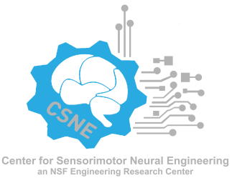
2017 CSNE/BL-BT SUMMER EXCHANGE PROGRAM – APPLICATION FORM

Please type or print clearly

Name (Last, First, Middle):
Address (Institution, Street, City, State, Country, Zip Code):

Date of Birth (Month/Day/Year):
Gender: M ___ F ___

Email Address: Telephone Number:
Current University/College:
Current Department:

Expected degree (e.g., B.S, B.A., M.Sc., Ph.D., M.D., Dr. rer. nat.):
Date degree expected:
Working towards this degree since (month/year):
Name of current faculty advisor:
Citizenship:

Will you need any special accommodations to participate in this program? Yes ___ No ___
If yes, please specify:

Please answer the following questions. (Maximum: 2 pages total)

- For CSNE students/postdoctoral researchers, which BrainLinks-BrainTools research lab(s) are you most interested in working with and why?

- For BrainLinks-BrainTools students/postdoctoral researchers, which CSNE research lab(s) are you most interested in working with and why?

- Why is this summer exchange program a good fit for you and your goals?

- If accepted, what do you expect to gain from the program?

